**LITERATURE SURVEY**

**TEAM ID : PNT2022TMID22772**

**TOPIC: REAL-TIME RIVER WATER QUALITY MONITORING AND CONTROL SYSTEM**

If water pollution is detected at an early stage, suitable measures can be taken and critical situations can be avoided. To make certain the supply of pure water, the quality of the water should be examined in real-time. Smart solutions for monitoring water pollution are getting more and more significant these days with innovation in sensors, communication, and Internet of Things (IoT) technology.

**CASE STUDY PAPER-PROPOSED SYSTEM:**

**Publisher:** Procedia Computer Science 155 (2019) 161–168

**Authors:** Mohammad Salah Uddin Chowdury, Talha Bin Emran, Subhasish G

hosh, Abhijit Pathak, Mohd. Manjur Alam, Nurul Absar, Karl Andersson, Mohammad Shahadat Hossain

The environment consists of five key elements e.g., soil, water, climate, natural vegetation, and landforms.

Among these water is the utmost crucial element for human life. It is also vital for the persistence of other living habitats.

Whether it is used for drinking, domestic use, and food production or recreational purposes, safe and readily available water is the need for public health. So it is highly imperative for us to maintain water quality balance. Otherwise, it would severely damage the health of the humans and at the same time affect the ecological balance among other species.

Water pollution is a foremost global problem which needs ongoing evaluation and adaptation of water resource directorial principle at the levels down to individual wells. It has been studied that water pollution is the leading cause of mortalities and diseases worldwide.

The records show that more 14,000 people die daily worldwide due to water pollution. In many developing countries, dirty or contaminated water is being used for drinking without any proper prior treatment. One of the reasons for this happening is the ignorance of the public and administration

and the lack of a water quality monitoring system which makes serious health issues.

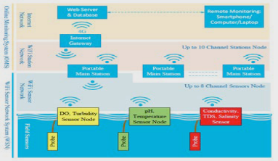

**This project uses a WiFi sensor network system(WSN) at remote places in river sites to measure pH, conductivity, turbidity level , dissolved oxygen,etc..to improve the water quality.**

**Following are the steps involved in this system:**

(a) To measure water parameters such as pH, dissolved oxygen, turbidity, conductivity, etc. using available sensors at a remote place.

(b) To assemble data from various sensor nodes and send it to the base station by the wireless channel.

(c) To simulate and evaluate quality parameters for quality control.

(d) To send SMS to an authorized person routinely when water quality detected does not match the preset standards, so that necessary actions can be taken.

**BLOCK DIAGRAM OF THE SYSTEM:**

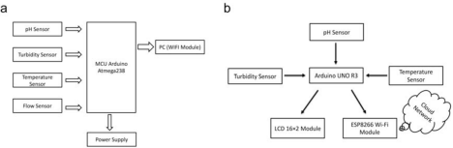(a)

Turbidity sensors, the pH sensor, the temperature sensor directly connected to the microcontroller are used for turbulence

measurement of water, pH measurement of water, checking the temperature of water accordingly.

The microcontroller collects the data and processes it with the Wi-Fi module.

The Wi-Fi module (ESP8266) transfers data to the PC where the data analysis is done. The LCD display has also displayed the output correspondingly.

(b)

The LCD display,ph sensor,turbidity sensor and temperature sensor is connected to the Arduino UNO R3.

The wifi module connected to the arduino uno ,shares wireless connection to the cloud to transfer information to the user.

**RESULTS:**

We are displaying the resulting sensed pH, temp, turbidity, and ORP values. It continuously senses the values of pH, temp, turbidity, and ORP and the resulting values are displayed to the LCD, PC or mobile in real-time. If the acquired value is above the threshold value comments will be displayed as ‘BAD’. If the acquired value is lower than the threshold value, comments will be displayed as ‘GOOD’.

A bar/line graph will also be shown for perfect understanding. The time series representation of sensor data with decision is given below

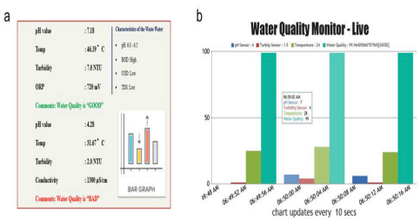

**COMPARING CASE STUDY WITH OUR PROJECT:**

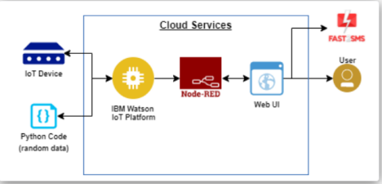

1. Instead of using Arduino ,we use IOT devices with Python code to connect with Watson IoT platform in exchanging the sensor data(ph value,temperature value etc)..

Disadvantage of Wifi Module:

● Frequency issues

● Limited bandwidth

● Limited range

Advantage of Watson IoT platform:

IBM Watson IoT Platform is a fully managed, cloud-hosted service that makes it simple to derive value from Internet of Things (IoT) devices. ● Handle enormous quantities of data.

● Improves performance + abilities by giving best available data

2. And Node-RED is used for better wiring connections

Node-RED is a programming tool for wiring together hardware devices, APIs and online services in new and interesting ways.

It provides a browser-based editor that makes it easy to wire together flows using the wide range of nodes in the palette that can be deployed to its runtime in a single-click.

Top reasons to use NODE-RED:

● Browser-based flow editing

● Written in JavaScript

● Enormous approval in the IoT space

● Web Application can be created using Node-RED Service